Understanding formulas, understanding what the binomial distribution is not:

I explored the formula in the following way:
Just plugged into different formulas related to the binomial distribution, different “value pairs” that had the same proportion.
This proportion I derived from my own expectation.

The possibilities combinations for 40 % of success or less from the total, do not make up 40 % of possible combinations from the total possible combinations. I confused the p-hat value with a label that had similar numbers (the success-rate of 40 % for which there will be a different number of successes depending on the number total number of trials).

CONFUSION SOLVED
We have no population and we have no answer!  In any case, population and sample would have the same size  Given the probability for a correct guess p=0,25 (relative probability)  The chance of getting 2 right (two right and one wrong)  →My sample would be three answers.  →”The population proportion is given, the population size not”  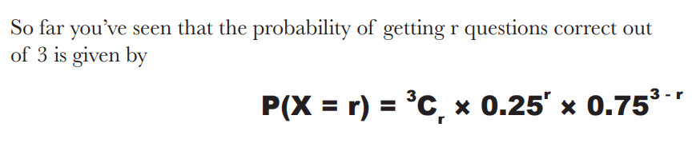 | Given a population proportion of 0.25 for red gumballs and a sample size of 100.  Given a sample distribution of proportion  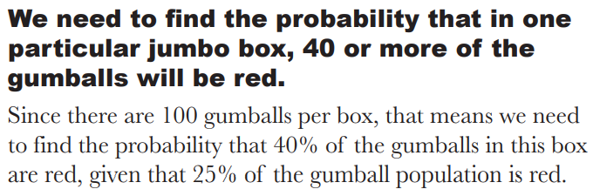
WRONG EXPECTATION
I expected to get the same result when computing != sample distribution of proportion given p = 0.25 sample size 100 and left sided limit to be 0.4.
This is not the case:
I don’t understand what the difference is between the two situations. One in which you use binomial distribution and the one in which you use the sampling distribution of sample proportion.

Thoughts during confusion
Understanding the settings of the task:  Is this an experiment? A Bernoulli experiment?  - Probability for 40 successes given 100 tries.  - The percentage of unique combinations, that do contain 40 successes for on hundred trials. |  | Understanding what is being calculated:  - The probability for a random sample of size 100, to have 40 or more successes  - The percentage (from infinity) of samples with size 100, having a p-hat of 0.4 or higher
What got me out of the confusion:
The expectation above was connected to the expectation, of getting for the same result, for different binomial distributions with the some proportion and where the number of successes made up the same percentage of the total number of trials.
Tried with this one:
Binomial Distribution Calculator - Binomial Probability Calculator, Binomial CDF calculations (gigacalculator.com)

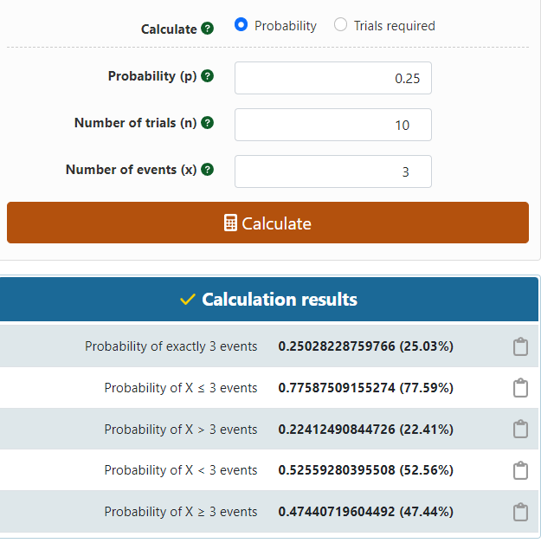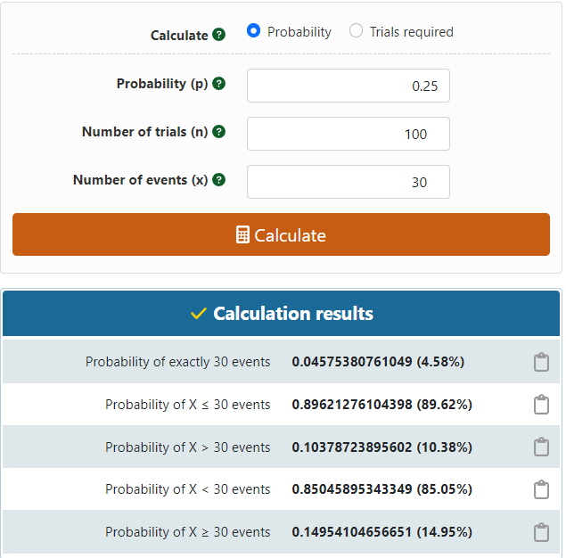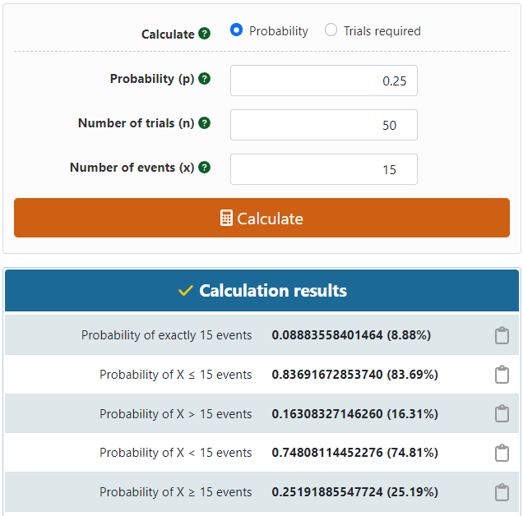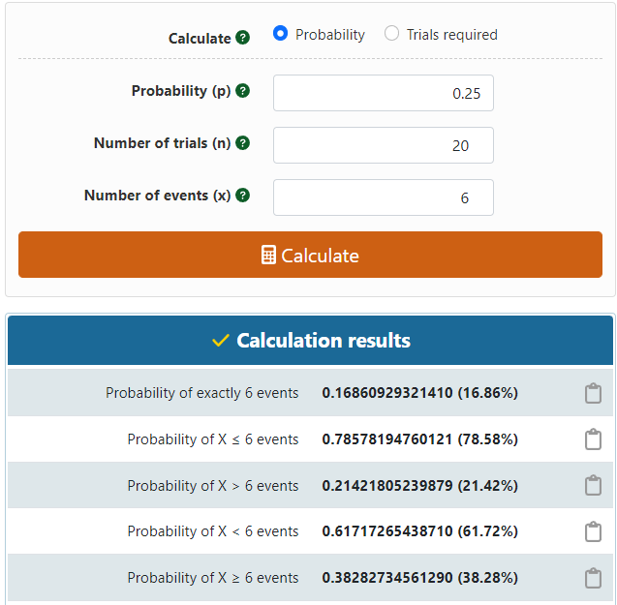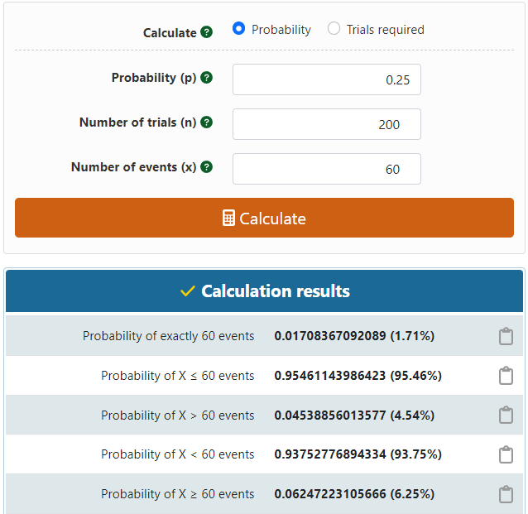
Überprüfung des Integrals für unterschiedliche Werte in denen der Anteila n erfolgen vom ganzen immer gleich ist!
definite integral binomial[1000,x] * 0.75^(1-x) *0.25^(x), x = 400 to x = 1000 - Wolfram|Alpha (wolframalpha.com)

Eingabe der Werte mit der Formel:
“definite integral binomial[1000,x] * 0.75^(1-x) *0.25^(x), x = 400 to x = 1000”

